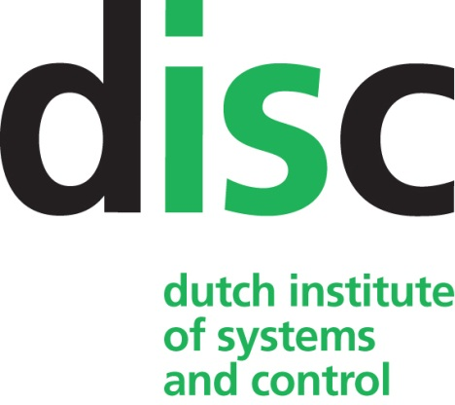

Program DISC Winter Course on
Reinforcement Learning

Delft University of Technology, Pulse building,
Technology Room
March 27-29, 2019

Wednesday, March 27, 2019
13.00 – 17.00 Ann Nowé Reinforcement Learning preliminaries

Thursday, March 28, 2019
09.15 – 09.30 Registration
09.30 – 09.40 Welcome and Introduction
09.40 – 11.15 Lucian Busoniu Forward-search planning
11.15 – 11.30 Break
11.30 – 12.30 Ann Nowé Reinforcement learning: part 1
12.30 – 14.00 Lunch
14.00 – 15.00 Ann Nowé Reinforcement learning: part 2
15.00 – 15.15 Break
15.15 – 16.15 Ann and Lucian Tutorial: Discrete-valued methods part 1
16.15 – 16.30 Break
16.30 – 17.30 Ann and Lucian Tutorial: Discrete-valued methods part 2
18.30 Winter Course Dinner at Café Belvedere

Friday, March 29, 2019
09.00 – 10.00 Lucian Busoniu General function approximation and application to model-based techniques
10.00 – 10.15 Break
10.15 – 11.15 Lucian Busoniu Function approximation in reinforcement learning
11.15 – 11.30 Break
11.30 – 12.30 Ann Nowé Deep learning introduction
12.30 – 14.00 Lunch
14.00 – 15.00 Ann Nowé Deep reinforcement learning
15.00 – 15.15 Break
15.15 – 16.00 Ann Nowé Multi-agent reinforcement learning

